PBI Relations & Filters
Contents
Discussion 1
Reference 4

Discussion
- DAX sample model - DAX | Microsoft Learn
- Examples in this article can be used with the sample Adventure Works DW 2020 Power BI Desktop model. To get the model, see DAX sample model
- Model relationships in Power BI Desktop - Power BI | Microsoft Learn
- CALCULATE function (DAX) - DAX | Microsoft Learn
- CALCULATETABLE function (DAX) - DAX | Microsoft Learn
- USERELATIONSHIP function (DAX) - DAX | Microsoft Learn
  - Cannot be used when row level security is defined for the table in which the measure is included.
  - Example: Override the default, active, relationship between InternetSales and DateTime tables.
  - To calculate the sum of internet sales and allow slicing by ShippingDate instead of the traditional OrderDate,
  - Create measure, [InternetSales by ShippingDate]
  - = CALCULATE(SUM(InternetSales[SalesAmount]), USERELATIONSHIP(InternetSales[ShippingDate], DateTime[Date]))
- Tutorial: From Dimensional Model to Stunning Report in Power BI Desktop - Power BI | Microsoft Learn
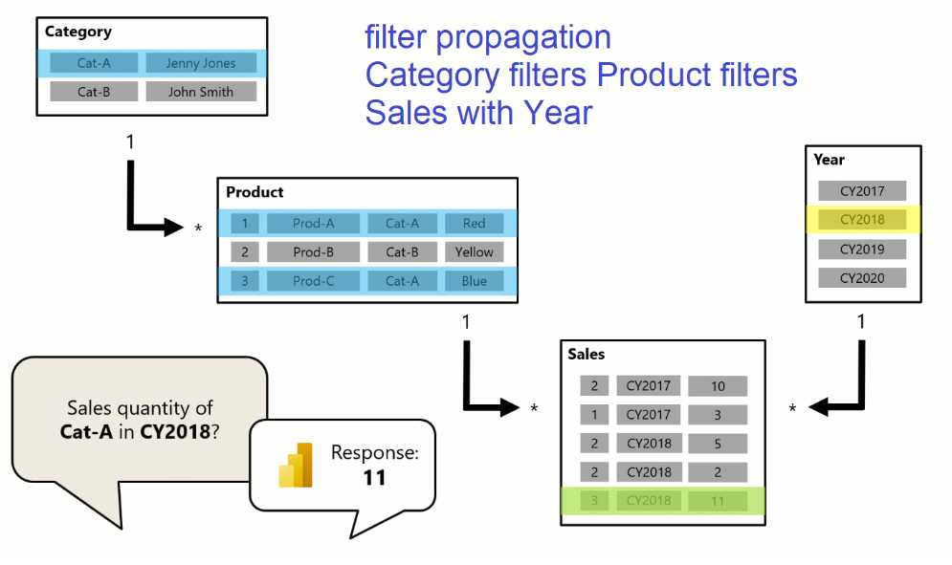
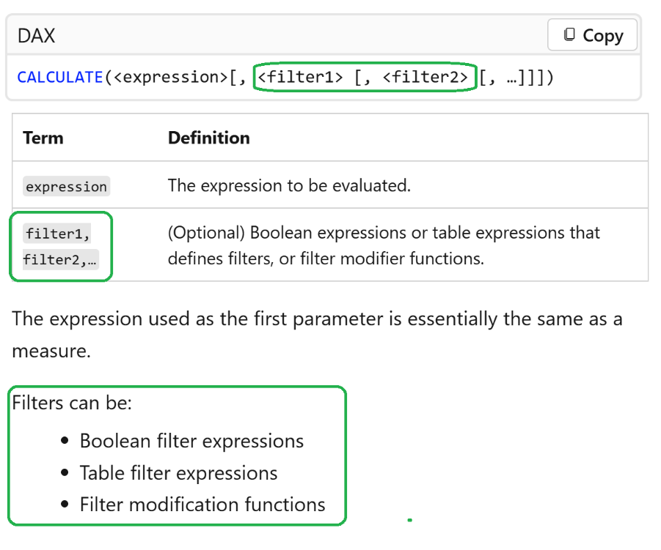
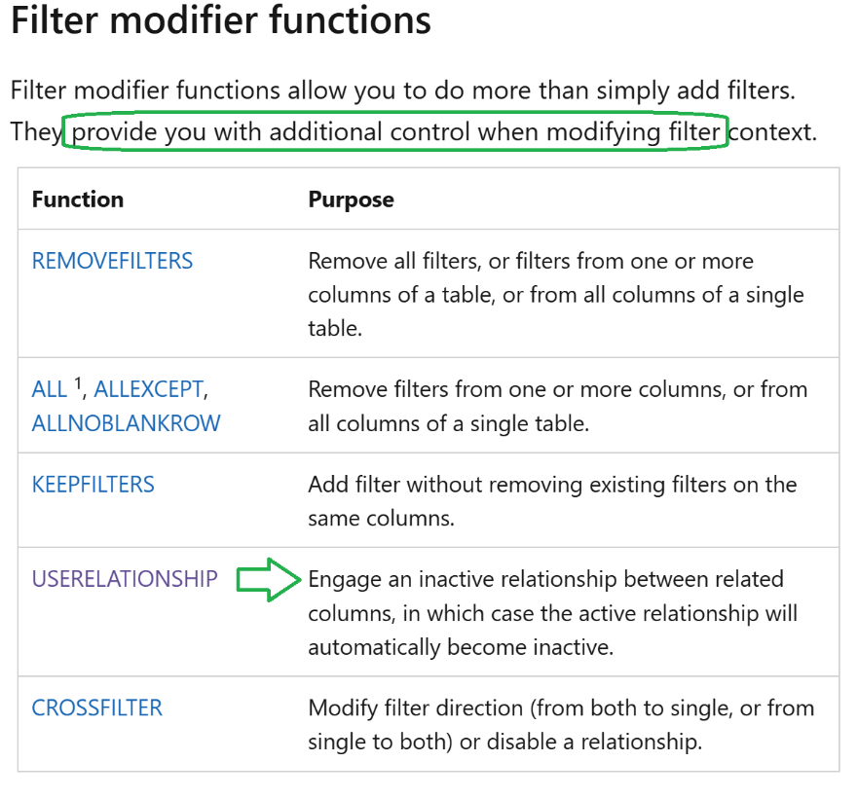
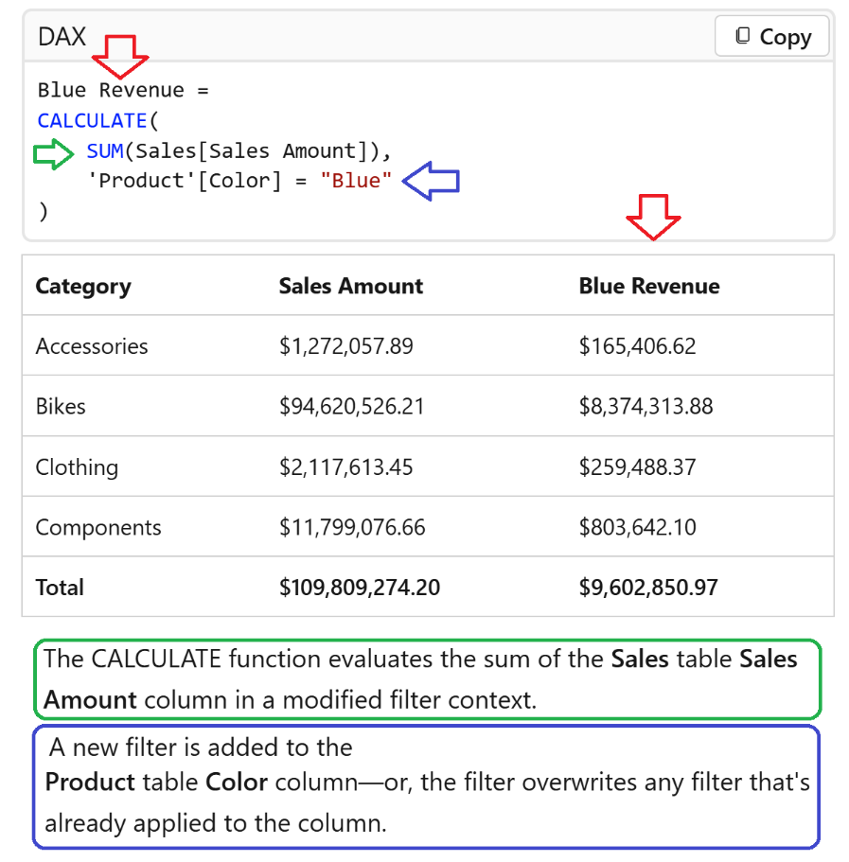
Adventureworks Example
In Power BI with AdventureWorks data, USERELATIONSHIP activates an inactive relationship (e.g., Shipping Date) to calculate metrics (e.g., Shipped Amount) alongside an active one (Order Date). Use a DAX measure with CALCULATE to temporarily override the model’s active relationship, allowing sales reporting based on alternate dates.
Scenario: Sales by Order Date vs. Ship Date
In the AdventureWorks model, the FactInternetSales table often links to the DimDate table via OrderDateKey (Active) and ShipDateKey (Inactive).
- Active Relationship: DimDate[DateKey]
FactInternetSales[OrderDateKey]
- Inactive Relationship: DimDate[DateKey]
FactInternetSales[ShipDateKey]
DAX Measure Example
To calculate the total sales amount based on the Shipping Date rather than the order date, create this measure:
dax
Sales Amount by Ship Date =
CALCULATE(
SUM(FactInternetSales[SalesAmount]),
USERELATIONSHIP(FactInternetSales[ShipDateKey], 'DimDate'[DateKey])
)
Key Details
- CALCULATE: The USERELATIONSHIP function must be used within CALCULATE or CALCULATETABLE.
- Override: The measure forces the relationship, regardless of whether it is active or inactive in the model view.
- Result: This measure can be used in visuals to show sales by Shipping Date, while a standard SUM measure will still show Sales by Order Date.
- Blank Values: Note that if an order has not shipped, USERELATIONSHIP will return a BLANK value for the ship date.

Reference
Exam PL-300: Microsoft Power BI Data Analyst - Certifications | Microsoft Learn
- Course PL-300T00--A: Microsoft Power BI Data Analyst - Training | Microsoft Learn
- https://github.com/MicrosoftLearning/PL-300-Microsoft-Power-BI-Data-Analyst
Analyzing & Large Report Example
- **Data, Probability and Statistics (mathsisfun.com)
- Ship INSIGHT (Container Ship) Registered in Marshall Is - Vessel details, Current position and Voyage information - IMO 9790907, MMSI 538007806, Call Sign V7ZZ9 | AIS Marine Traffic
- Filter a report using query string parameters in the URL - Power BI | Microsoft Learn
- **Data, Probability and Statistics (mathsisfun.com)

